Was it Dream part Two
After Marsha and I entered the house, Tory was now where to be found. At that point, I told Marsha I had to use the rest room and I’d meet her in the living room. I found the room I was looking for and went to take care of business. During that time my mind was racing, picturing various scenarios of what might transpire when I come out. Anyway, I finished washing my hands and left the bathroom. As I entered the living room, I was totally surprised by what I was seeing. Tory had Marsha naked and up against the wall, playing with her pussy.
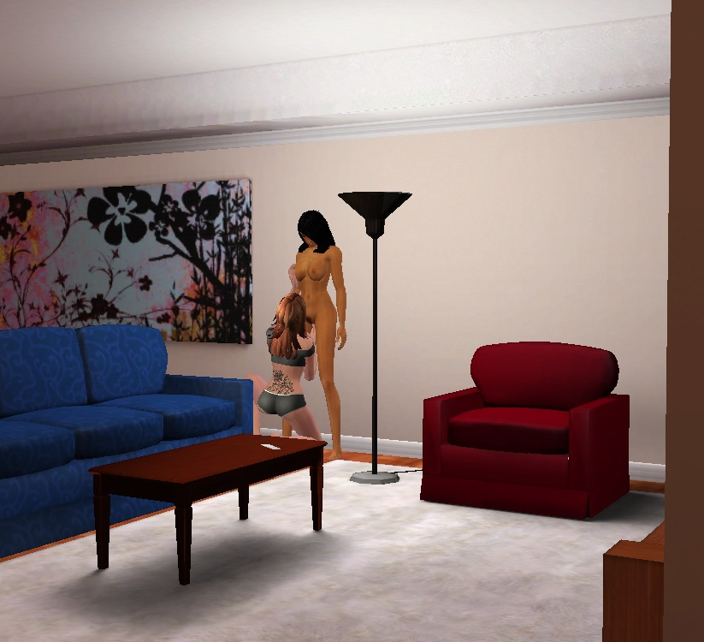
Naturally, I stopped and watched for a bit.
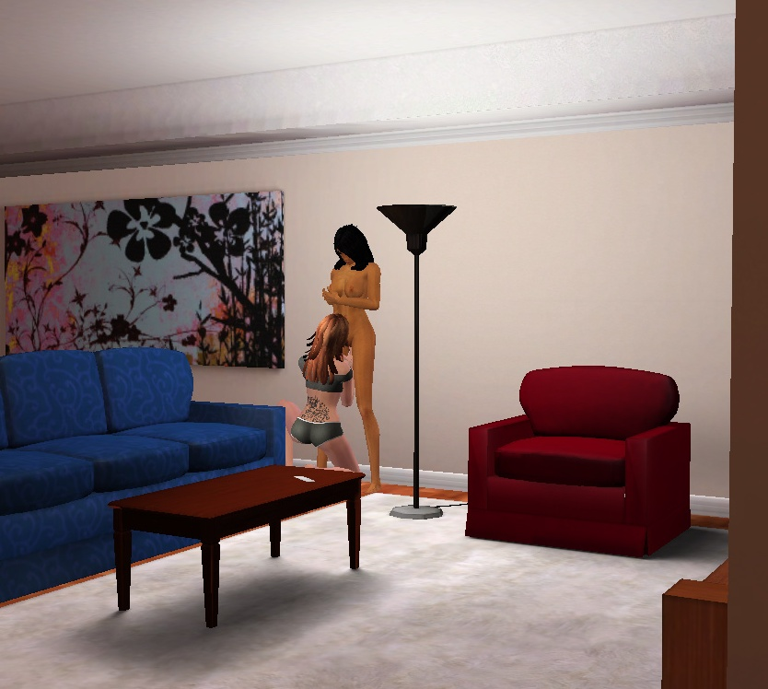
I got closer to watch the action.
Next thing I knew was Tory just picked Marsha up and carried her to the dining room table and began licking Marsha’s pussy like there was no tomorrow. It was as if I wasn’t even there.
At first, Marsha seemed a bit surprised by Tory’s actions; I then began to sense that Marsha was getting into all this attention.
As Tory licked her pussy Marsha took her left hand and pulled Tory’s head to her pussy so Tory’s mouth could engulf the whole thing. By this time, Marsha was writhing on the table and moaning with pleasure.
I could tell Marsha was having an orgasm because of her movements. Hell, I had a hard on from just watching all this and, they both knew I was watching. I could not believe these women worked in the same office as me, I thought to myself. After Tory made Marsha cum over and over, she stood up and said, “Marsha it’s his turn,” as she pointed at me and left the room. Marsha took one look at me and without batting an eye she said, “Why are you still dressed? Take your fucking close off so I can suck your dick.” I did as she commanded, and Marsha got on her knees and proceeded to go to work on my cock. She was driving me crazy with her tounge.
As she was licking my member all up and down the shaft, she kept saying, “I want you to fuck my brains out.” This was blowing my mind, I thought today was going to be just another day at work, but no, the God’s had something else in store for me and I was going along with whatever it was at this point. Next thing I know Marsha is pushing me to the floor. Where she climbs on top of me and begins to ride my cock like a pogo stick.
All I had to do was lay there and hold on. As she was moving she was staring me in the eyes and playing with her breasts saying, “Fuck me, fuck my pussy hard,” over and over again. Shit, it was all I could do to keep from exploding inside her. She rode me like that for what seemed like an hour, because of her stare I got lost in her blue eyes. She just kept staring at me even when she began to cum over and over again. At one point I thought she was going to collapse, then she asked me, “Are you ready to cum?” and I said, “Yes.” She stopped and stood up and grabbed me by the cock and led me to the couch and proceeded to give me head again.
As she started, she said, “I want you to cum on my face.” I just sat there and enjoyed what she was doing. Feeling her lips wrapped around my shaft as she pushed my cock deeper and deeper into the back of her throat. She stopped and began licking the tip of my cock which drove me even closer to shooting my load.
Between stroking my cock with her tongue she kept repeating, “Cum on my face, cum on my face.” Well it happened after she said that five times. I shot my load all over here face.
All I could think was wow! This chick is a freak!

