Meet Tory, she is an insurance adjuster and normally dresses very conservatively. Although you can tell, she has a wild side.
Meet Marsha the new girl. I am not sure exactly what it is she does yet but she has only worked at the company for a few weeks now.
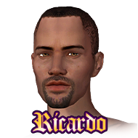 This is I; I am a customer account executive. I handle new accounts and maintain existing ones generated by our sales team.

